|  |  |
| --- | --- |
|  | YEAR 11 CHEMISTRYInvestigation: Alcohols as fuelsValidation Test for Fuels Investigation |

**Name ........................................................................**

|  |  |  |  |
| --- | --- | --- | --- |
|  | **Your marks** |  | **Marks** |
| **2. Validation test** |  |  | **40** |
| 1. **Write up**   **Handed in, complete**  **Handed in, incomplete** |  |  | **5**  **2** |
| **Total** |  |  | **45** |

**You will submit your practical book on the day of your validation test.**

**SECTION 2**

Amanda decided to investigate the heat of combustion (in kJ/mol) released on burning 6 different alcohols. She used the set up shown in Figure 1. She weighed out approximately 100 g of water, noted the temperature before and after heating with the alcohols, as well as the mass of the spirit burner before and after heating. She obtained the results in table 1 on the next page.

**Figure 1:**

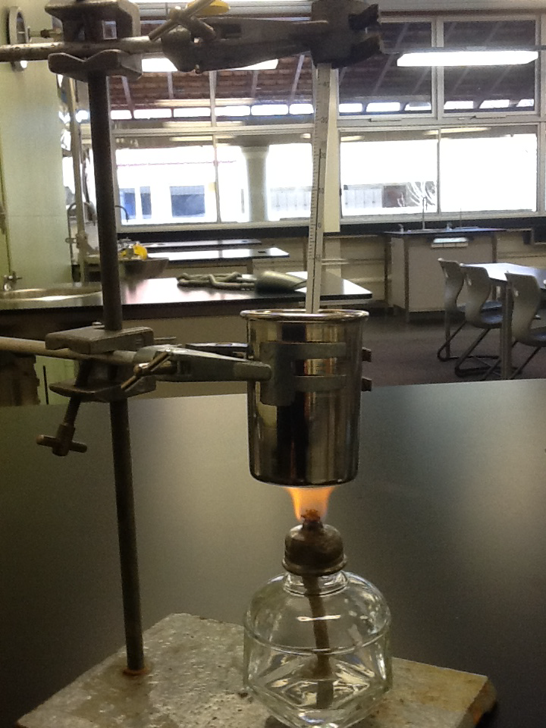

|  |  |  |  |  |  |  |  |  |
| --- | --- | --- | --- | --- | --- | --- | --- | --- |
|  | **Mass of fuel at start (g)** | **Mass of fuel at end (g)** | **Mass of fuel used (g)** | **Mass of water (g)** | **Temp at start (oC)** | **Temp at finish (oC)** | **Temp change (oC)** | **Energy produced (kJ)** |
| Methanol CH3OH | 222.858 | 222.242 | 0.616 | 102.054 | 22 | 30 | 8 | 3.412 |
| Ethanol C2H5OH | 185.880 | 185.208 |  | 104.632 | 21 | 32 |  |  |
| Propanol C3H7OH | 212.183 | 211.827 |  | 102.027 | 21 | 30 |  |  |
| Butanol C4H9OH | 183.891 | 183.678 |  | 100.005 | 21 | 30 |  |  |
| Pentanol C5H11OH | 206.062 | 205.673 |  | 101.052 | 21 | 31 |  |  |
| Hexanol C6H13OH | 229.470 | 229.150 |  | 101.260 | 21 | 30 |  |  |

1. Complete the table using the following equation: (5)

**Energy =**

**mass of water x specific heat capacity of water x temperature difference**

**(specific heat capacity of water = 4.186 Joule/g °C)**

1. Identify the independent variable for this experiment: (2)

....................................................................................................................................

....................................................................................................................................

1. Identify the dependent variable for this experiment (2)

....................................................................................................................................

....................................................................................................................................

1. Based on your experience of your own experiment, describe HOW Amanda

might have controlled three variables (3)

....................................................................................................................................

....................................................................................................................................

...................................................................................................................................

1. Based on your knowledge of energy processes involved in bond breaking and forming, what was Amanda’s hypothesis? (2)

....................................................................................................................................

....................................................................................................................................

....................................................................................................................................

1. Calculate how many moles of fuel have been used in each experiment. (6)

**Table 2**

|  |  |  |  |
| --- | --- | --- | --- |
|  | Molar mass of alcohol (g/mol) | Moles of fuel used  (mol) | Energy per mole (kJ/mol) |
| Methanol CH3OH |  |  |  |
| Ethanol C2H5OH |  |  |  |
| Propanol C3H7OH |  |  |  |
| Butanol C4H9OH |  |  |  |
| Pentanol C5H11OH |  |  |  |
| Hexanol C6H13OH |  |  |  |

1. Plot Amanda’s results in an appropriate graph using data from table 2 (6 marks)



1. One of the results is anomalous. Put a ring around the anomalous result and estimate a value for this result: ............................................................... (2)
2. What was a valid **qualitative** conclusion that Amanda was able to make based on her results? (1)

....................................................................................................................................

....................................................................................................................................

....................................................................................................................................

1. What was a valid **quantitative** conclusion that Amanda was able to make based on her results? (1)

....................................................................................................................................

....................................................................................................................................

....................................................................................................................................

1. Using your knowledge of bond energies, explain Amanda’s results. (2)

....................................................................................................................................

....................................................................................................................................

....................................................................................................................................

1. Explain why it was necessary to calculate the moles of fuel used in table 2. (1)

....................................................................................................................................

....................................................................................................................................

....................................................................................................................................

1. Reflecting on table 1 and your own results, describe three sources of experimental error (3)

....................................................................................................................................

....................................................................................................................................

....................................................................................................................................

....................................................................................................................................

....................................................................................................................................

....................................................................................................................................

1. Describe two possible improvements of the experimental method. (2)

....................................................................................................................................

....................................................................................................................................

....................................................................................................................................

....................................................................................................................................

1. Apart from fuel efficiency, what other factors might be important in considering a particular alcohol as a fuel? Explain your answer. (2)

....................................................................................................................................................................................................................................................................................................................................................................................................................................................................................................................................

**END OF TEST**